Functional Society Vision Fostered Today
  Sharing Cultures by Osmosis  A mathematician recently proved the most effective way to spread information in a network, was to have occasional long-distance links feeding into very dense local links.  ð Discuss how culture spreads when a person with a long-distance link lives among a neighbourhood that knows and interacts with itself deeply, and whether this encourages or diminishes cultural diversity and relevance. Contrast this with the effects of travel today and the tendency toward a single global monoculture. | 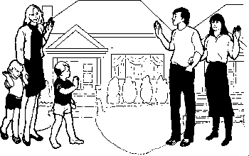  Know Your Neighbours  Though people live in cities surrounded by millions of people, never has individual isolation been greater.  ð How many people live within 100 metres of you?  ð Of those people, how many do you think would make fantastic buddies with common interests?  ð If instead of travelling large distances to reach your friends, you formed your friendships from people on your doorstep, what would be the effect on your life, sense of community and psychological security?
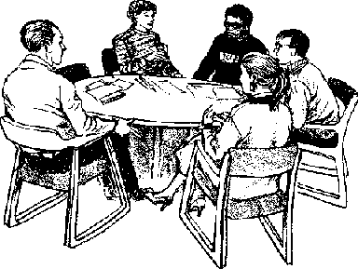  Administration  When communities are deeply organised and interactive, decisions of all kinds are best decided and carried out by the people concerned.  ð Discuss the role of radical devolution of decisions to well-functioning tighly-knit communities, and the role of a worldwide governing architecture to facilitate and administer the diversity that results. | Communal Inheritance - Staying Around  Each generation should build up neighbourhood connections to pass on to their children who develop them further for handing on to their children.  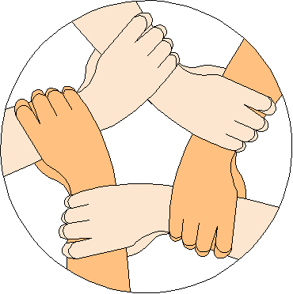  ð Discuss the implications of people moving around every few years on the ability to build up functioning neighbourhood communities.  ð What is the effect of people not knowing their neighbours on crime and security?
  Community Type  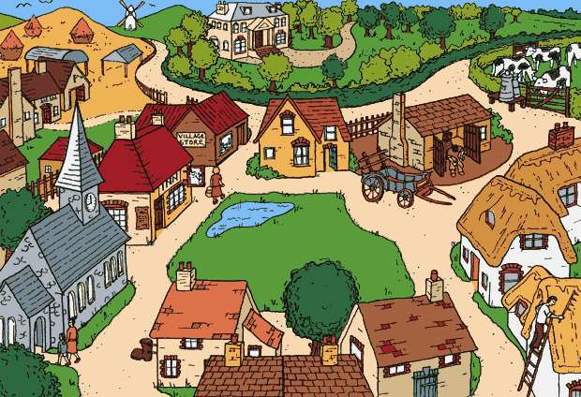  ð How do villlages surrounded by woods and natural space, compare to neighbourhood districts within cities? |   Bahá'í Faith  The Bahá'í Faith is a growing embryo, whose purpose is to provide an experience and vision of community cohesion with a global vision and organic interconnectedness, that will provide a vision to the world, and as it increases, an example working community.  ð Explore how you can foster a Community reality amongst your family, neighbours, friends, colleagues and the world around.
Community Size    A community should be small enough such that wherever you walk you generally know people well, yet large enough so that you are always meeting new people.    ð Discuss this ideal  ð How big does this mean a village or community district should be?  ð Try to envisage and share through examples what you feel the resulting daily dynamic and community experience would be in such a size community. |   Relationships and Family  A sign of a dysfunctional, disconnected society, is that relationship breakdown has little effect. In a neighbourhood where everyone knows each other deeply on good terms, relationship breakdowns are disastrous to the living and creative dynamic.  ð Discuss this, and the role of having family members nearby in the sustaining of marriages and the role of family consent toward a marriage.  ð Explore bringing up children in a society where everyone knows each other, compared to one where everyone are strangers.  ð Explore how the purpose of relationship to a partner is transformed when you know all your neighbours.
Technology  ð How to cars, televisions, internet, mobile phones, facebook, etc, currently affect our building up real, close-knit communities?      ð How might this be improved or changed? | Your Ideas  Website : http://www.davidmerrick.co.uk Email : http://www.paintdrawer.co.uk/Email.php

