The Birth and Call of Jesus
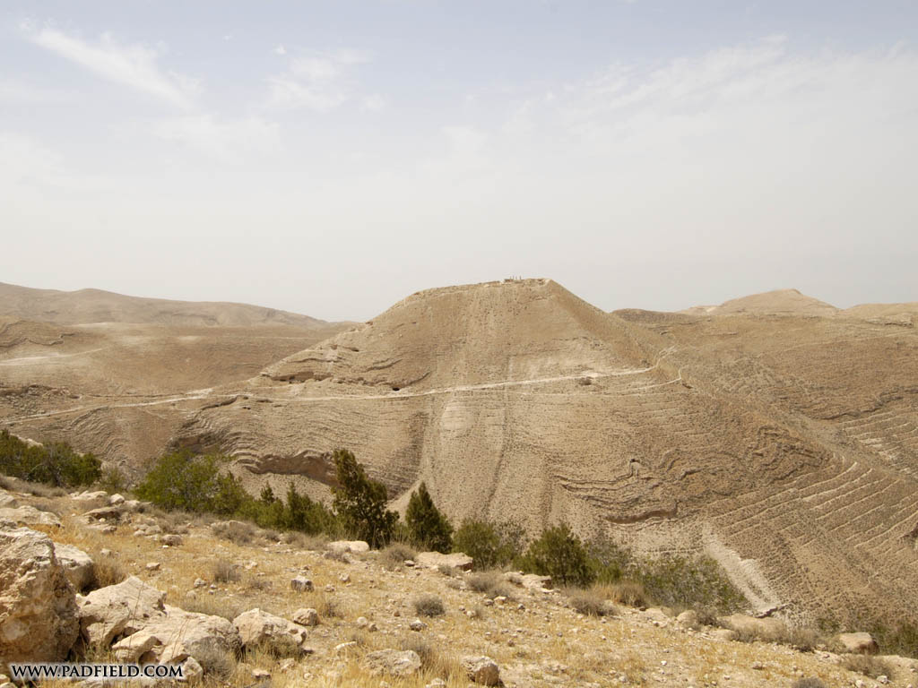
This is the story of the birth of Jesus and His great call to the world of humanity. The sources used to tell it, are the four canonical gospels, Josephus (with the Old Slavonic), and spiritual insight. Where the accounts are contradictory or vague, a best endeavour has been made to resolve the story and make it flow.
In the original language, the names of Jesus, John the Baptist and Mary were, Yeshua (Joshua), Yokhanan and Mariam.

Story of Moses
In the long distant past, a sandstorm of oppression, idolatry and superstition engulfed the Egyptian lands, blinding the spirit of its peoples, and crushing their souls.
Amidst this deathly shroud of inhumanity, the shining influence of Moses broke forth like lightning, and His light penetrated the dark shadows of the storm. He melted the chains of ego and self from those whose hearts were pure, and led them out upon the highway of justice and oneness, guiding them through the wasteland of persecution and abasement; until at last, they attained the Promised Land of the soul, set free as a single community, united in a nobility of thought, freedom of spirit, and heavenly endeavour.
After His Ascension to the luminous world, Moses blazed forth ever more brightly in the radiance of the Spirit, and lit up the hearts of His followers with the light of heavenly guidance. But their hearts gradually turned from His ways, and were enveloped in the thick veils of the world. Deprived of the influence of the Spirit, the challenges of disunity, success, ego and materialism, confronted their purity, and strengthened the wise, and they were bound again in the heavy chains of superstition and imitation, flung into the darkness of self, and left with their faces in the earth. Prophets rose up in the power of the Spirit of Moses, chastising the strong and comforting the weak, crying out for people to disregard imitation, ego and oppression, and turn in humbleness to purity, devotion, and hope. Some listened, and followed in the path of justice and love, whilst many turned their backs and hastened to their demise. In their disunity of spirit, the land became humbled by foreign invaders, and the people carried away into exile, until finally, two thousand years ago, it was seized by the Imperial armies of Rome, and became the province of Judea.

Announcement of John
Now at this time, there lived a priest with his wife; who with great devotion in their hearts, loved and served the ways of God.
And yet, they were very sad; for they had grown old without a child. Many of those they loved and daily served, imagined God wished to end their family line, holding it in distaste; and they felt this both with a keen pain, deep within their heart.
One day, during this priest's time of service in the Great Temple, it was his turn to enter the hidden chamber, and burn the incense for the people.
As the great crowd remained in prayer outside, the priest prepared everything within. Suddenly, he felt the presence of an angel standing on the right of the incense altar.
Surprise and fear overwhelmed him. The angel however reassured him, saying his prayers had been heard, and that his wife would have a child. This extraordinary child would be a source of great joy, and would make the land ready, turning the people toward God and wisdom; he would live in great frugality, and would be raised and led by the spirit at all times, and would go by the name of John.
The priest and his wife were both old, and in his heart he was filled with doubt. Wanting to feel sure the news was really true, he asked to have a sign.
The angel was grieved that he should doubt, standing as he was in God's presence and shining with His Light, and made the priest know that he would have a sign suiting his lack of sight.
The priest remained inside the temple for some while. As the time drew on longer and longer, the people outside began to become extremely anxious and restless. They were not permitted to enter the Temple, and unaware whether he were alive or dead, they hung in the wild grip of imagination.
At long last, the priest came out, clearly shaken, indicating to the large and noisy crowd without a word, what had happened.
In due course, his ministry in the Temple was complete, and the priest again returned to his home. His wife conceived, and so she withdrew herself from public for five months.

Announcement of Jesus
Now the wife of the priest also had a cousin, living not far away in a village. She was a young lady, named Mary, and she was engaged to be married to Joseph, a man whose ancestry placed him well in people's eyes.
It was just a month on, that Mary herself experienced a profound and unexpected vision, which awoke her deeply in her soul. In her vision, a heavenly messenger disclosed that she would have a son, a most great soul, bearing the greatest sovereignty of the Spirit; Whose name would be Jesus.
Mary was still only engaged, and she wondered how this promise of a child might be. She understood within her heart that such a wondrous soul would come through the great power of the Spirit, and in the vision she learnt that her cousin, the wife of the priest, was also in her old age bearing a child. Mary was satisfied, and she humbly submitted to the Will of God, and the vision departed from her.

Mary Visits Elizabeth
She gathered up all her necessary things, and journeyed into the hills in haste; through there, she made her way on to the city where her cousin lived. As she arrived, her cousin's baby leapt within, and both women in their joy filled the air with song-filled gratitude to God.
Mary continued to stay with her cousin, and after about three months, she returned again to her own home.

Joseph's Reaction
Rumours arose and then spread everywhere that Mary during her time away, had been unfaithful to Joseph. Joseph was devastated, for she was engaged to him. With so much convincing talk, he was unable to accept her tearful pleas. He was a conscientious man, however, and did not wish her to suffer the brutal fury of a public outrage; he restlessly turned over within his mind how he might break off the engagement, and secretly send her away from harm.
As these things raced through his mind, and her explanations wrestled violently with his anger, frustration and disbelief, one night he felt in his dreams the presence of God comforting him, assuring him of her innocence, and the truth of what she said.
Gathering to himself his strength and humility, he made his peace with Mary, and standing by her against all public opinion and wild rumour, he married her.

Birth of John
In due time, Mary's cousin gave birth to a son. Having suffered so long the public shame of being childless, their new fortune was now the source of great joy to their neighbours and relatives, who felt they were standing fully in the love and grace of God.
The eighth day arrived, and the child was brought forward to be named. His father was very old, and everyone agreed that the child should carry his name into the future.
His mother however, stood apart, and insisted that the baby should be called John. The room was filled with astonishment and confusion, and everyone protested vigorously, that she had no relatives of that name.
The child's father was watching everything in silence. At last, they sought his decision on the matter, and he called for a writing tablet, and wrote out that his name was John, adding to everyone's astonishment at the parents' extraordinary conduct.
The father, who for so many months had spoken nothing, suddenly broke his silence in praise of God, and the whole scene bewildered everybody present, and became heard of far and wide. Everyone wondered to themselves, what kind of child John would grow up to be, and what light he might bring to their country in the dark times of Roman rule.
As John grew older, his spirit grew strong. Much of his time, he spent in the wilderness, and in his adulthood he went forward before all the land and summoned the people to the Call of God.

Birth of Jesus
Six months after John's birth, Mary too was soon to give birth. At this very time, she had to make a tough and dangerous journey with her husband, and travelling down the river valley, passing by Jerusalem, she eventually came to Bethlehem.
On her arrival in town, she searched for a place to stay. Even though she was ready to give birth, no one was willing to give her a place to rest, and she delivered Jesus in a stable. Mary wrapped Him up, keeping her Child warm and clean, and laid Him in the trough used for the animals.
Some of the shepherds in the fields were watching their flocks, and in the night darkness were filled with awe as they experienced a vision of the concourse in heaven, celebrating the glory of the God now come into the world. They immediately set off and discovered where the Child lay, and spoke to everyone about what they saw.

Naming of Jesus
After eight days, this Child of the Spirit was named Jesus. His parents took him up to Jerusalem, and presented Him to God with an offering. A spiritual man of some age was there, and he recognised the Child's presence. Praising God, he took Jesus in his arms, and spoke of what was to be, whilst a woman who was living at the temple in continual fast and prayer, told them also of His destiny.

The Wise Men
So they journeyed back again to their relatives in Bethlehem. Some men came in to Jerusalem from an eastern country, and they were asking people regarding the King God had chosen over them. The king of the land was seriously ill, and he was in constant fearful watch for anyone who might try to take his throne from him. When he heard these claims of kingship, he became very anxious, and with him most of Jerusalem. So he called together the Jewish priests, and he insisted on knowing where the King would be born; then summoning the strangers, he privately sent them off to Bethlehem on his behalf. On their arrival in that town, they found the young family, and fell down in submission before the Child, presenting Him their treasured gifts of gold and incense.
They spoke of the king's desire to learn where the Child was, and knowing the king's perverse character, it was very clear to everyone that his real plan was not to see this Child. In a dream they were inspired to go a different way home, rather than return to the king, and Joseph for his part took the young Jesus with his mother away by night, far from harm.
The king had been awaiting all he needed to know, and he was quite furious when the strangers did not return to him. He went to great lengths to find out where Jesus was, and in his mad pursuit of this fear, he grew ever more desperate, until at last he had all the young children in and around Bethlehem seized and their lives ended. Such a weeping of mothers and fathers, brothers and sisters filled the air that day, blackening all hearts for years to come.
A short while later, after a life of intrigue and struggle, the king himself died of his illness, and Joseph was inspired to arise, and take his wife and Child back home again. When he heard, however, that the king's son ruled in his place, he was afraid, and they made their way into Galilee.

Jesus Debates at the Temple
Year by year, Jesus grew, and He amazed all the people with His strength of spirit, wisdom and grace of character.
His parents travelled to Jerusalem each year, attending the Feast of the Passover. When Jesus was twelve, He was travelling with them, and after the Feast had finished, they all returned home in a large company. As they journeyed, they were unaware that Jesus had stayed behind in the City, and a whole day passed before they noticed His absence. At first, they sought Jesus amongst all their relatives and acquaintances, and when they were still unable to find Him, they were forced to turn back to Jerusalem.
After three days of searching, they at last found Him in the Temple, sitting amongst the scholars, hearing them and stirring them with profound and challenging questions. As Jesus easily resolved many of their intricate and long-standing problems, everyone was astonished at His insight.
Jesus' parents saw Him, and after their long search they were both very upset. Seeing all the scholars gathering around Him, they were amazed, and asked Him why He had brought them such anxiety. Jesus responded:- Surely, they must understand He has to be about His Father's work.
His parents did not understood these words, and they took Him home to Nazareth, where He submitted to their commands. Yet His mother was full of wonder, and could not put from her heart all the things she saw of Jesus and His wonderful wisdom; and as He continued to grow, Jesus' reputation increased daily amongst the people.

John's Mission
Meanwhile, John lived in the wilderness, and he had no thought for himself. Like a wild man, he dressed in camel's hair, wore a leather strap around his waist, and ate mostly locusts and wild honey. At Passover, he would not eat the bread, for it had simply been made that way out of haste in their ancient flight from slavery; nor would he draw near wine or meat. Every wrong thing, he stood against.
When John reached about 30, the Jewish age of maturity, he arose in the Spirit of God, preaching to everyone around that ritual, social position, ancestry and fine words gave a person no favour with God, but only a pure and repentant heart overflowing with real, sacrificial love for one's fellow man and fairness in all things: to free themselves from mortal law and be ruled by heavenly law. People flocked from all over the country to see him, recognising and accepting how far they had missed their mark, confessing aloud and within their hearts to God. They asked John what they should do, and he told them to share whatever they had with those who had less, to act justly, meekly, honestly, and patiently. John immersed them in the great Jordan River, drowning out their old ways, so that from the River of the Spirit, they might arise a new person, in commitment to a new, spiritual life; and as a deep hint of what was to come: for it was John's ardent desire that everyone would be prepared for the arising of the Great One who would set them free, who walked even then amongst them, the very brilliance of whose presence judged all things.
Many of the religious leaders also came to the waterside to visit John. When John saw them, and sensed how far they fell short of the ordinary people they looked down upon and directed, he spoke up and challenged them clearly with how they should conduct themselves.
Many people began to think John might himself be the Great One sent by the Spirit, who would rescue the land from its slavery. John answered them, that he was cleansing them just with water, a hint to their minds and hearts: there was One coming, mightier than all, Who immersed the soul with the living, creative Spirit of God, whose sandals he was unworthy even to look upon.
As people arrived and returned to their villages and cities, rumours and stories began to spread like fire amongst the people, causing great hope and confusion.

John is Questioned by Authorities
Several priests were chosen and sent out from Jerusalem itself, to ask John who he was. Every position and label they put to John, he denied, saying only, "I am the voice of one crying in the wilderness - 'Make straight the way of the Lord!'".
John was brought before the authorities and an assembly of doctors of Law, They asked him who he was, and where he has been until then. John said, "I am clean. The Spirit of God leads me, and I live on roots and canes of plants and trees." They threatened to torture him if he would not cease from his mission; but he rebuked them, saying, "It is for you to cease from your terrible works and turn to the Lord your God."
One of the Scribes named Simon responded in anger; "We read every day the holy books, and you come from the wilds like a wild animal, how dare you try to teach us, and mislead the people with your destructive words." He rushed upon him with violence; but John rebuked them. "I will not disclose to you the mystery among you, for you have no desire for it. An unspeakable calamity is to come upon you, because of yourselves."
And when he had so spoken, he left and went out to the other side of the Jordan River; and while no one dared rebuke him, he continued with his work.

Dream of the Eagle
One night, one of the rulers dreamt he saw an eagle, which tore out both his eyes. He summoned all his wise men, and they each interpreted his dream differently. Suddenly, without being summoned, John arrived dressed in his ragged wear, and said: "Give ear to the word of the Lord, The dream you saw - the eagle - that is your corruption, like an eagle, violent and seizing. And that sin will take away your two eyes, which are your dominion and your wife." And as he had so spoken, death seized him that very evening.

Jesus Baptised
Then one day Jesus Himself came forward, to be immersed in the river. John was aware that Jesus was the Great One who had come into the world, and he was aghast at the idea, and forbade Him, saying in great humility, how he himself was in need of being plunged by Jesus into the river of the Spirit. Yet Jesus reassured him, and instructed John to continue. Jesus immediately arose from the water, praying, and John in the inner vision of his soul, saw the heavens break open, and the Great Spirit like a dove descend and rest upon Jesus, and a voice shone forth from the inmost heavens, saying, You are my beloved Son, in Whom I am well pleased; whilst those all around continued to look patiently upon John, and await his guidance.

Jesus Attracts Disciples
The next day, John was looking upon Jesus with love, as He walked. "See, the Lamb of God," he sighed.
Two of John's disciples, hearing this, followed Jesus. Jesus turned, and seeing them following, He asked them what they desired. "Your honour," they asked, "where do you stay?" So Jesus lovingly bade them come with Him, and as it was late in the afternoon, they stayed with Him for the day.
What spiritual wonders they felt and heard that night in Jesus' home, as they listened spell-bound to the melody of every word He uttered. They lost all interest in John, and wanted only to remain at Jesus' feet, yearning to do whatsoever He might need of them.
Unable to contain himself any longer, one of the two sped out to find his brother, and in a great state of rapture told him how he had found the One promised by Moses, and ushering him back to Jesus, Jesus looked upon him; seeing the faith concealed within his heart, Jesus gave him a new name - Peter, the Rock.
Jesus went into Galilee, and there He summoned another man, who was so wholly inspired by everything he felt and heard, ran out to inform his friend. His friend, in great amazement at what he heard, came to see for himself, and as he approached, Jesus was filled with delight, remarking upon the great sincerity of his spirit. As He spoke, He quickly won him over, his whole heart and mind.

Wedding at Cana
Now not far away, marriage preparations were underway, and Jesus' mother was present for the occasion. Jesus too was called, and His disciples came with Him.
In the very midst of the wedding festivities, a terrible calamity arose; for the wedding guests had flushed themselves so full with wine, the wine had run out entirely, and Jesus was summoned by His mother to respond to the disaster.
Jesus distanced himself from any involvement with such a matter, responding frostily to the idea; but His mother persisted, knowing how her Son would have to obey a mother's command, and she directed the servants to do whatever Jesus might require. So He simply instructed the bewildered servants to take the water from the stone washing basins, and they served it out to the drunken guests. The lord of the feast himself, full of wine, tasted the water, and calling up the bridegroom, declared in amazement that it was surely the finest wine at the Feast!

Cleansing of the Temple
Time rode on, and as the great Jewish Feast of liberation approached, Jesus joined the great stream of pilgrims as they travelled up to Jerusalem along the long river valley.
Arriving in the City, Jesus found the Great Temple of God had become a buzzing hive of commerce, money-making and superstitious trade, and He saw its courts filled with people busy selling extravagantly to the great mass of pilgrims gathering there for the solemn Feast.
Jesus made a scourge of small cords. He drove out all the dealers from the temple, and set free the sacrificial animals far and wide; He emptied all the money-changers' money onto the ground at the pilgrims' feet, and threw over all the tables, declaring with great authority:- "Take these things away from here! My Father's house is not a marketplace!"
The Jews were in great shock and horror, and they asked Jesus what sign He could show them to justify these challenging actions; referring to the Spirit of God on earth, and Its triumph, Jesus instead challenged them: "Destroy this temple, and in three days I will raise it up."
The Jews could not possibly understand these things, and replied in amazement that it had taken them forty-six years to build, and He was planning to rebuild it all in just three days!
Many in Jerusalem became devoted to Jesus through His actions there and His striking words, but knowing their desires and fickle hearts, Jesus did not take up their support.

Jesus and John Baptising
After some days, Jesus headed back out from Jerusalem, and His disciples joined in with John and supported his undertaking, washing people in repentance and expectation of the approaching Call of God.

John Promotes Jesus
John's following was widespread; but Jesus' disciples were now outshining his work, and John's followers felt strongly the eclipse of their master. They asked John about Jesus' activities, and John spoke up in great favour of Jesus' success, saying that it was now time that he himself must decrease, and be overshadowed.
As word of Jesus' success spread, the clergy became fearful and envious, and Jesus departed further away from the City toward His home through the forbidden lands, and many received Him on His journey there.

Temptation of Jesus
Awakened in the fullness of the Spirit, and preparing Himself for His great mission of sacrifice, Jesus lived for many weeks amongst the wild beasts of the wilderness with nothing to eat. Challenged with affliction and great hunger, facing the immense task ahead, He was aware of His ability to use His limitless power and spiritual authority for His own comfort - to create from nothing bread to eat, to seize the material kingdoms of a world that would soon be ranged against Him, to follow the ambitions of Self in preference to God - and yet to do so would be to hope to seize a Power for Himself that was not His, and this He refrained from doing, placing Himself entirely at the command and desire of the Spirit.

Imprisonment of John
Now at this time, John held sway over every heart and the people were ready to do whatever he should wish. The king of the land, however, was a brutal and self-seeking individual, and he lived in fear of John's position to raise a country-wide rebellion. With great courage, John took the king to task without any restraint regarding his public misdeeds: particularly the king's taking his brother's wife; all the doctors of the Law were revolted, yet dared not accuse the king before his face. John alone came to the king, and in anger rebuked him, "Why have you taken your brother's wife! As with your brother's pitiless death, because of your adulterous lust you too will be reaped off by the heavenly sickle. God's decree will not be silenced, but will destroy you in foreign lands." When Herod heard this, he was furious and had John beaten, and driven away. But John accused the king to his face incessantly, wherever he found him. Because of these things, the king sent out soldiers and had John arrested, bound, and brought back to him.
To make their way smooth, the king and also his wife sought to have John killed. The king however was afraid of John's popularity with the people, and so his wife was unable to persuade him to put him to death. John's frankness and fairness stood out in contrast to everyone else who offered him advice, and soon the king began to go to John for real guidance to all the difficulties he faced, and took whatever he said to heart.
John's ability to melt the king to repent of his selfish designs before he could begin to carry them out, became a constant and frustrating obstacle to the king's progress, and it made him appear weak to everyone around. So the king one day in a great rage sent John to the fortress of Macherus, on the summit of a very high and impregnable hill, surrounded by harsh and desolate wilderness.
The news of John's imprisonment in due course reached Jesus, and He Himself departed into Galilee.

Jesus' Public Declaration
The fame of Jesus spread out to all the people. He taught in the synagogues, and He proclaimed everywhere how the long-awaited time had arrived, and everyone must now turn their hearts to the purest and noblest goals, and enter the kingdom of God through spirit, and faith.
As He walked beside the sea of Galilee, He saw two brothers casting their net into the sea, and a little further on, two other brothers mending a net; Jesus summoned them, and they left their nets and followed Him.
Returning to His birthplace, on the day of resting, Jesus made His customary visit to the synagogue, and He stood up to read.
He was given a book of the Prophet Isaiah, and opening it, Jesus read:
"The Spirit of the Lord is upon me, for He has anointed me to preach the gospel to the poor; He has sent me to heal the broken-hearted, to preach deliverance to the captives, and recovery of sight to the blind, to set at liberty them that are bruised, to preach the acceptable year of the Lord."
Jesus closed the book, gave it to the minister, and He sat down. All eyes were fixed upon Him.
"This day," declared Jesus, "this scripture is fulfilled in your ears."
As they heard Him speak further, they were overwhelmed by the grace of His words, and astounded by His meagre upbringing. Soon He spoke of the spiritual poverty of their generation in the eyes of God and many things they could not bear to hear, and they one and all rose up, and they dragged Jesus out of the city toward a cliff to throw Him down. Yet His majesty overwhelmed them, and He passed safely through their midst, and continued upon His way.

Widespread Proclamation
Jesus travelled throughout the country, into cities and villages, and wherever He went, huge crowds gathered around Him, astonished and transformed by His beauty, and the wisdom and Spirit they felt surge within their souls when they felt the attraction of His love. He engaged people with stories and principles, urging them to wash away all trace of self, and enter into the love of God and serve all people. Gentle to the meek, yet stern to the proud; such were His ways, the beauty of His speech, and the effects of His presence on those around Him, that He seemed clearly to be the centre of God's outpouring of grace and justice to all around.

John Sends Messengers
John's disciples brought news to John in his prison of Jesus' spreading fame. John selected two of his disciples as witnesses, and sent them out to visit Jesus, so that they would carry out to all the remaining companions still following John, what they had experienced and felt with Him.
On reaching Jesus, they asked if He were the One they were awaiting, or another?
Jesus continued His work, and they experienced the beauty of His presence and the transformation He brought to all those around Him. The spiritually blind found their eyes awakened, those who were lame in life's immortal journey, began to walk forward; social outcasts were cleansed of their rejection, and those deaf to all truth began to hear; the spiritually dead were raised into a state of illumination and nearness to God, and beggars were made rich in the knowledge of His message. So illumined and transformed were all souls, that in becoming spiritually whole, many cast off lifelong burdens of the body and mind, and from their inner strength arose in full health. Seeing all these things, John's messengers departed on their way filled with the stories of many wonderful outpourings of the Spirit through Jesus to the people.
Jesus spoke out to His listeners of the greatness of John's mission, and his simple frugality; and He praised even more the standing of those who would now rise up, and enter the canopy of the new revelation He was bringing, the word and spirit, made living in every breath and step of their lives.

Martyrdom of John
Now it was the king's birthday one day, and a meal was spread out for all the powerful people of the land.
The wife the king unlawfully married, had a daughter, and she came in and danced. The important guests were filled with admiration, and the king was very pleased, so he promised her on oath she could have anything she pleased.
She left the hall and went to her mother, and she asked her what she should get. Her mother told her to ask for John's head, and she returned speedily to the king, and asked him before the whole company, for John's head on a plate. The king was greatly distressed, but felt bound to honour his oath in front of all his guests, for whom such an act meant little, and the slightest hesitation would display weakness and fear before a prisoner.
The king immediately sent for the executioner, and commanded him to do what she asked. The executioner left the hall full of guests, beheaded John in the prison, and returned with John's head on a plate for the king's daughter, and she carried it to her mother.
Hearing the news of this horrific event, John's disciples came and took up his body, and laid it solemnly to rest within a tomb.
The Jews around deeply resented John's execution, and they saw it as a terrible offence against God. When the king's army was afterwards destroyed, the Jews saw it as the avenging justice of heaven.
Jesus' companions gathered themselves around Jesus, and told Him of John's sad fate, and what they had been doing, and how they had been teaching the people.

Life, Betrayal and Martyrdom
Many supposed that Jesus was John the Baptist come back to life, and hearing of His astonishing fame, the king himself greatly wished to see Him.
From amongst His followers, Jesus chose twelve companions to be close by Him, hear His deepest wisdom, and spread His message throughout the land.
The leading clergy, eclipsed by Jesus' brilliance, felt their influence rapidly disappearing to a people they once commanded, and they feared how the Roman empire might respond in force to a wide-scale commotion. For three years they followed Jesus' activities and at every moment sought to shame Him or put Him away, yet always they failed. Eventually one of them, fighting with doubt and ego, betrayed Jesus to the clergy. They seized and bound Jesus with great force, and led Him before a secret trial, and they had Him crucified mercilessly and in great humiliation. He was hung up to His death upon the main highway into Jerusalem at the very height of their Festivities when all the Jews came to the City, a spectacle for all to see.

Growth of His Cause
At Jesus' death, the hearts of His disciples wavered, and they lost all hope and hid themselves in fear. In a short time, they regained their faith and connection to His ever-living presence, now released from the limitations of the earth, and they arose together to share His Spirit and message amongst a world of people enslaved by fear and ego, shuffling in the night shadows of a dark and gruesome empire that fed people to starving animals for public entertainment, crucifying large numbers across the countryside and along the public roads - an empire where every person feared each daily step in life.
Inspired by His message and example, Jesus' disciples arose to crucify their own ego and self interest, and resurrect the land; in their meekness and energy, they showed people a new way of personal love, courage, justice and responsibility, emblazoned through Jesus' life and spirit, His death on the cross shining through all as the way to life - a death that tattooed the sacrifice of self and comfort within the living hearts of every ordinary person for many centuries to come.

Info
Author : David Merrick, Edinburgh
All comments appreciated : http://www.paintdrawer.co.uk/david/Email.php
Notes : http://www.paintdrawer.co.uk/david/folders/Spirituality/001=Christianity/Birth%20and%20Call%20of%20Jesus%20Christ%20(Notes).htm
This Version : 2026-07-30 15:05
Latest Version : http://www.paintdrawer.co.uk/david/folders/Spirituality/005=Collections/holydays.htm
See Also : Sources

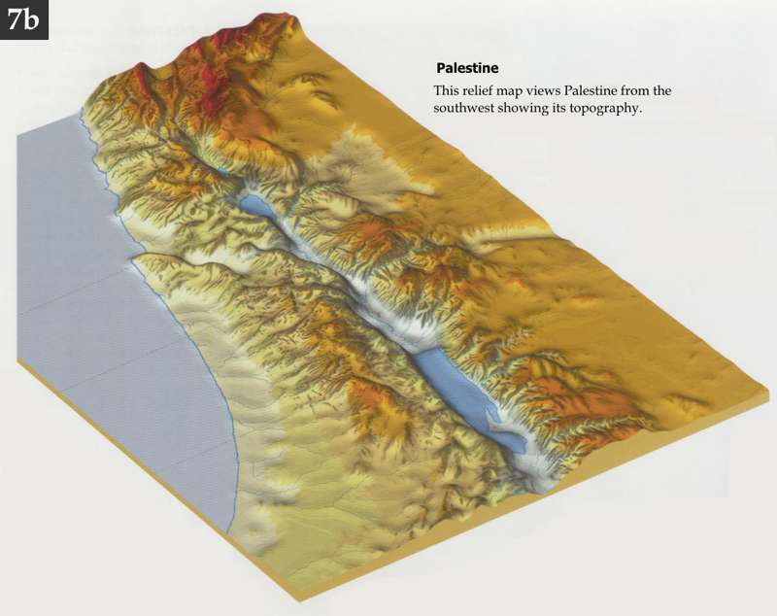
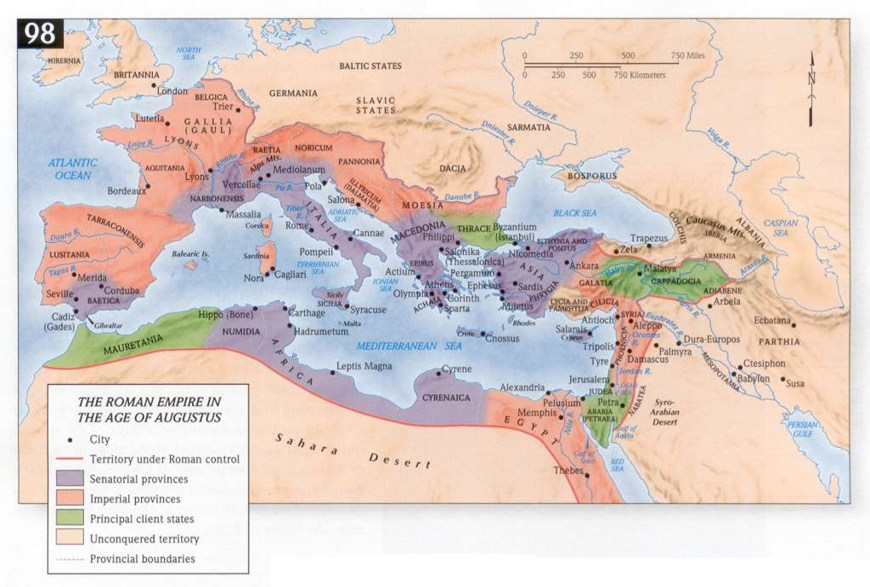
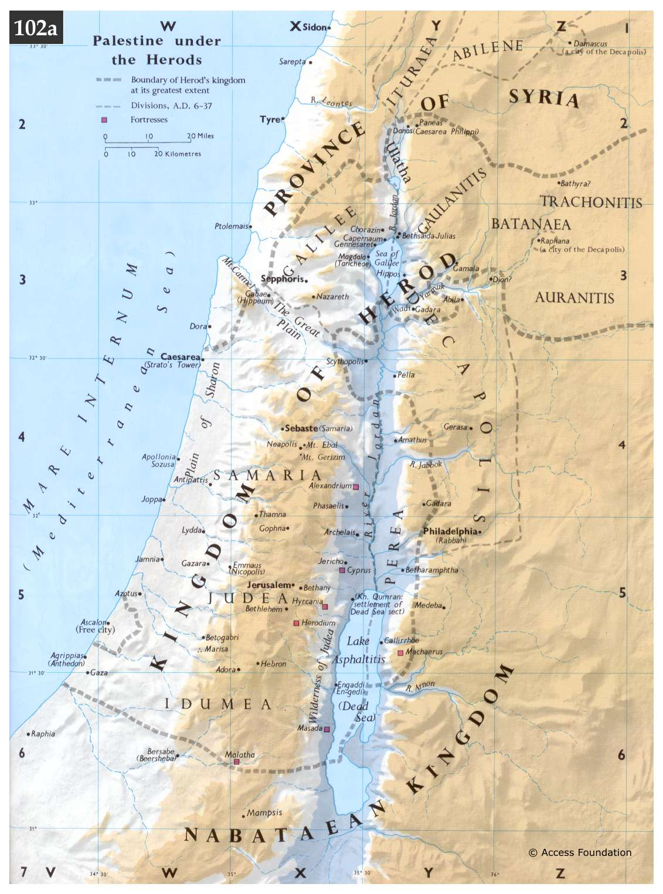
Palestine in the time of Herod
Roman Empire under Augustus
Jerusalem
Nazareth

Photos
Macherus, on top of which John the Baptist was imprisoned

River Jordan.
The King was exiled to Gaul.

