Life After Oil ?
When oil runs out - embracing the next few decades
This includes the questions used in the workshop, with some comments on each

What lifestyle have you been brought up to expect for the coming years?
Ever-increasing travel, lots of energy and its uses, food, comfort, and few worries.
What do you think you will get?
An unprecedented, devastating human calamity, when a rampantly-growing complex world suddenly finds all its fuel and energy disappears.
What types of Fossil/Unsustainable fuels do we use?
Oil, Gas, Coal, Nuclear.
What do we use them for?
Absolutely everything - Fertiliser, planting and harvesting, travel and transport, materials and construction, city life, heating. All that you see around you, near and far, is through oil and its kin.
Name the things you don't use them for?
Symbolic things, such as arts and crafts with your neighbours using naturally available materials, and philosophical reflection.
Summarise how we've build the world?
Humans have a habit of building houses on quicksand and doing quite unsustainable things, and none is more extraordinary than founding modern society on the assumption of a limitless supply of freely-available energy, when we know it's due to disappear.
Energy hit the world like paper thrown onto embers. The embers burst into fire roaring high in a bright blaze of exciting flames, called modern civilisation. But it can only last as long as the energy does, and as soon as the paper is consumed, the fire dies back, and everything returns to embers again.
The discovery of energy and its end, is a bit like a great earthquake, which caused the tide to recede rapidly into the distance. Everybody rushed onto the beach to collect the corals and pearls; they felt they wanted to be there forever and built their homes on the sand surrounded by these pearls. Everybody in the world, in envy, are pouring out in a rush onto the beach to join them, just as the sea is flooding back to sweep everything away and return it to how it was.
Plentiful energy came... and likewise, it has its end.
Here's a cartoon illustrating the blind state of denial and hope the world currently lives in:
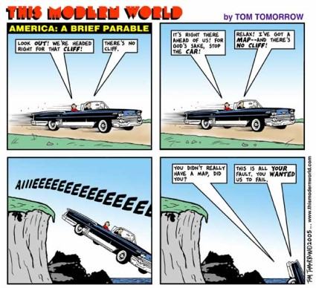
Modern life runs on cheap, readily-available energy. What if energy doubled in price? became 10x more expensive? or its availability unreliable?
People would scarcely use it, except in exceptional circumstances. People would not habitually travel, except by simple means such as foot or horse. The recent modern world dependent on long-distance transport, travel and material commerce, would become paralysed and evaporate as if it had never been.
How many people in the world want to take up our flamboyant Western lifestyle?
China (1 bn), Asia (1 bn), and later Africa (1 bn), and these are populations now - they are rapidly increasing. China's demand grows 8% yearly. This joining of the train creates a rapid rising of demand for energy.
Here's a world population map for 2050. Consider which segments will be wanting to join in with using lots of energy:
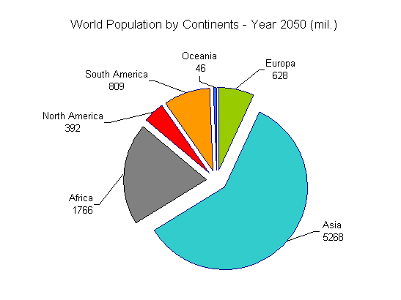
How does world population effect energy use? how fast is population growing?
In 2030, there will be double the population of 1980. Simplistically, this too doubles the demand for energy.
Here's a typical graph of world population, whose sudden explosion has been supported by free energy, agricultural revolution and medical advances. If energy disappears, the world falls into turmoil and sanitation problems become rampant, population will return back to a more normal state. If you think about how that will occur, it will not be a happy matter for anyone.
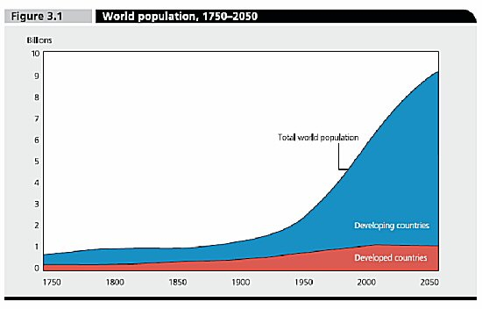
Globally, are we decreasing or increasing our dependence on unsustainable energy?
Demand for oil is projected to increase by 40% from 2006-2030.
When in the picture of things, do problems set in?
Energy supply in the world takes the shape of an umbrella (see graph below). It grows, as we supply more and more; and then peaks, and then declines, as we supply less and less.
You'd think problems occur right near the end, when supply has dwindled and become small; but the problem actually happens at the peak, just when energy availability is greatest. At that point, people rapidly want more and more, yet there's suddenly less and less and the people look down at the precipice that lies before them.
Our material lifestyle is a bit like pushing a very heavy cart. It seems so easy to push it down a hill, and at its easiest point, you hit the level ground, you can still push it. But when you try to push it uphill... you can't; you come to an abrupt stop. Our lifestyle seems easy to do because it is carried for us by plenty of energy; but as soon as that goes away, no one in their right mind would think of continuing in such a lifestyle as we live. If you had to cycle to produce all the energy to fly you to another country, few would fly abroad. So when energy is not abundant, what we have will be treasured, and people's lifestyle and expectations will be very different.
Below is a typical growth and decay of an individual country's fuel production, the US, which once led the world in energy. Notice how easy it was to predict, and how shocking it was when it came. Of course, the US found it could then turn to imports from abroad. But when world fuel, which follows this same shape, disappears, there will be no outside source to turn to:
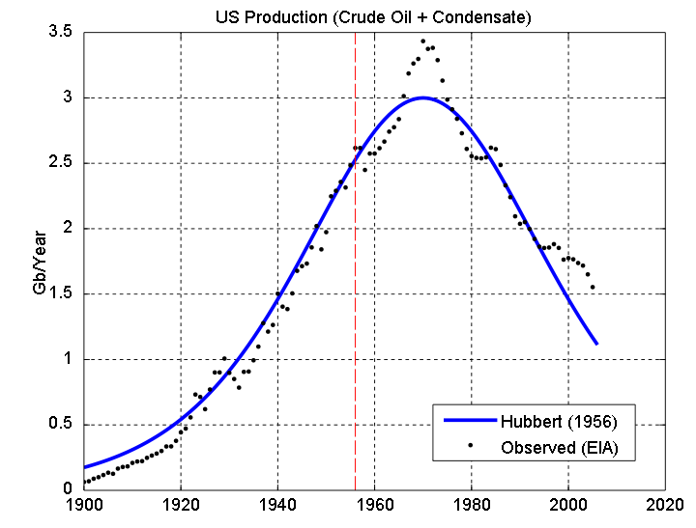
This shows how lots of countries' predictable rise and fall of energy production combine to make a single world graph of exactly the same predictable shape:
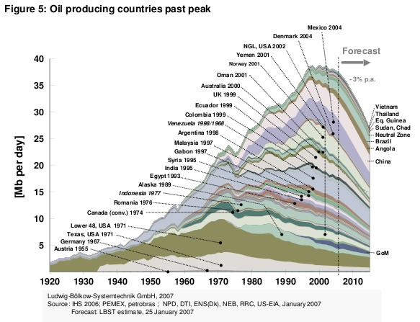
How long is there left for our unsustainable energy sources to peak and go into decline?
There have been no new major oil finds since 1960s, and reserves (i.e. all technically possible but uneconomical sources) peaked in 1980s. We are using up oil at 4 x the rate of discovery.
Optimists using officially quoted information, say the peak will be in 20 years. For example, the IEA (International Energy Agency) says there will be severe restraints beginning 2010, rapid oil price increases, an oil crunch and then the peak will follow in 2020.
Many others, based on observations and revelations from oil insiders that official figures are simply lies, say the peak has already just passed, or is just about now.
Here's a typical prediction for the future:
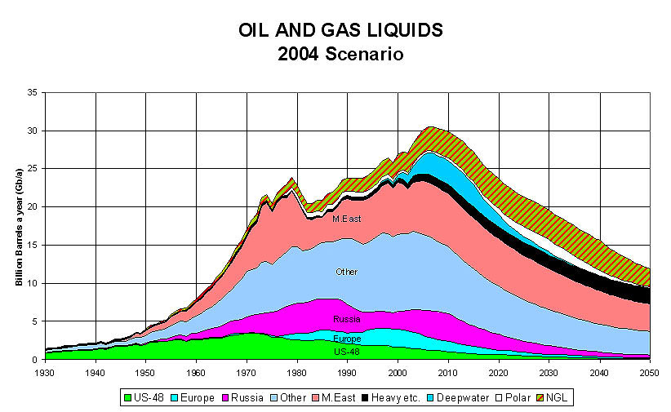
What do the insiders say?
Exxon-Mobil company spokesman, Dec 2005: "All the easy oil and gas in the world has pretty much been found. Now comes the harder work in finding and producing oil from more challenging environments and work areas."
Saudi Arabia's King Abdullah told his subjects in 1998: "The oil boom is over and will not return... All of us must get used to a different lifestyle." Since then he has implemented a series of corruption reforms and government programs intended to lower Saudi Arabia's dependence on oil revenues. The royal family was put on notice to end its history of excess, and new industries were created to diversify the national economy.
Former head of Saudi Aramco's production and exploration, stated in an Oct 2007 that oil production had likely already reached its peak in 2006, and that assumptions by the IEA and EIA of production increases by OPEC... are "quite unrealistic". That, "World reserves are confused and in fact inflated. Many of the so-called reserves are in fact resources. They're not delineated, they're not accessible, they’re not available for production"
A Saudi Aramco spokesman admitted its mature fields are now declining at 8% per year (national composite decline of 2%). This information has been used to argue that the largest oil field in the world and responsible for approximately half of Saudi Arabia's oil production over the last 50 years, has peaked. The world's second largest oil field, entered decline in Nov 2005.
Why would companies and countries overstate what they have?
The oil companies tell the world what oil reserves they have, and no one checks what they claim is true. Can you really imagine checking up on places like Saudi Arabia? They just state what they've got, and the world uses them as official figures.
When it was agreed that what you can sell should be linked to what you have in reserves, the oil producers' quoted reserves suddenly doubled overnight. This gives their figures very little trust.
It's in their interest to look good to everyone, so that they are high on the stock market, well-invested in, have prestige, and avoid people downscaling their energy use and turning to other sources.
So really, any "sensible" oil company in this situation, would simply invent the figures to meet requirements and tell everyone their reserves were fine, keep selling their oil until it had completely run out, and then suddenly say one day with a smile, to a shocked world, "Hey sorry guys, it's all gone now; goodnight, you're on your own!"
The graph below shows quoted OPEC reserves. Notice how what they quote conveniently doubles overnight, and figures don't seem to change despite huge output and declining production, as typified by the quotes above. It looks like they are simply quoting whatever they want the world to hear.
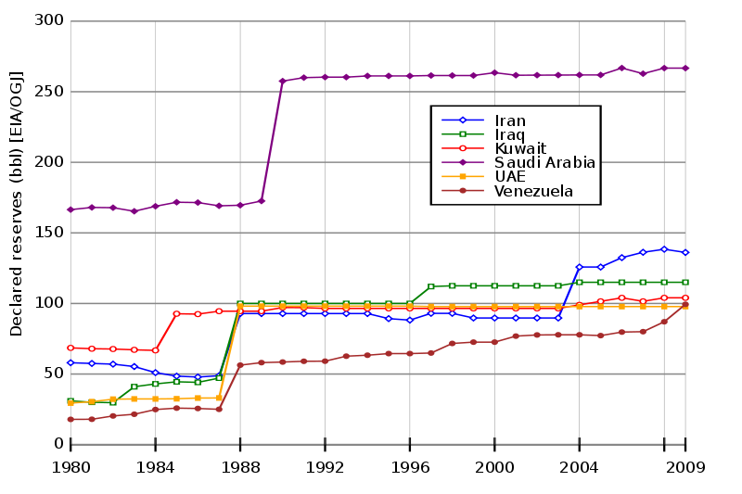
What would happen if you took away our energy tomorrow?
Few know how to grow or find food, or really keep warm: there would be famine and few would survive the winter. Lack of sanitation, disease, chaos, anarchy and gangs would be rampant, and all modern business would come to a halt; cities would become unsustainable and evaporate as people flee.
What is the common vision people have of when Fossil Fuels disappear?
Most people imagine a gentle decline in fossil fuels in some distant, hazy future, with natural, sustainable resources replacing it so that no one notices the changeover.
Will the decline be sudden or swift?
It is likely to be swift. Oil may decline steeply but not like a cliff, however human psychology ensures otherwise. Think what would happen if you told people the food was now going to run out. All supermarkets and foodstores would be cleaned out overnight.
The reality is that when it looks like oil is peaking and declining, the oil exporters will simply cut off the world from its energy supply and keep it for themselves; and in the anarchy that follows, they'll then realise they have to keep it solely for their military, so even their own public would not have it.
So there's a good chance due to the way humans work, that when the panic sets in energy will disappear almost overnight.
Governments are undoubtedly aware of this to different degrees, which is why there's such a push towards nuclear power, which itself may peak out shortly in just the same way as fossil fuels, and in addition presents an impossibly expensive decommissioning problem.
Politically, the world will become run by energy politics and issues of security, and human beings may well become a secondary concern.
This very dramatic graph may be closer to what will happen than we hope.
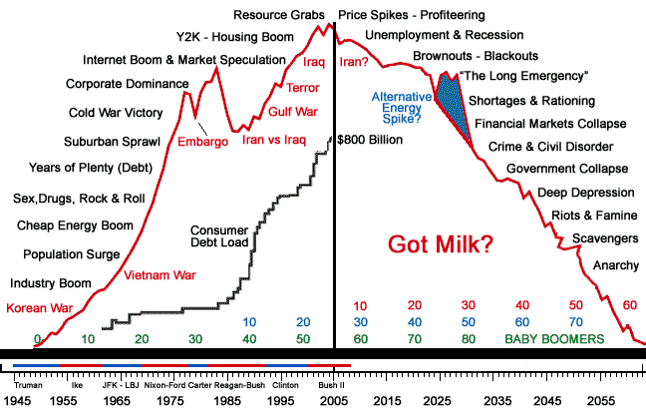
Here's a graph of ever-rising nuclear fuel demand and its supply peaking and declining:
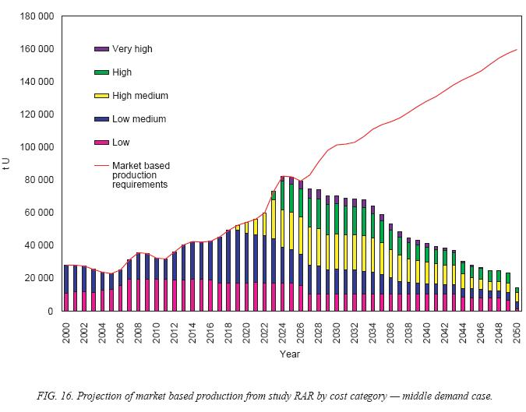
BUT WAIT! What natural, sustainable energy sources do we have instead?
Wind, Water, Heat, Solar, Fuel Crops, Geothermal.
How long would sustainable energy alternatives take to develop and implement?
In a stable, energy-filled world, making use of fossil fuels, you could fill the world up with windmills and solar panels etc, but it would take some time and a lot of resources and planning. But we will, and likely have, left it too late, and in a turbulent world of anarchy from energy-shortage and climate change, it will be a formidable challenge to do any such thing.
Are sustainable energy sources a good replacement for our current, unsustainable sources?
Generally speaking, except in a few lucky countries, a resounding No.
How much wind do you think it would take to push a 40 ton lorry up a slope? from this you can see how much energy it takes to power even one lorry. Yet a cupful of petrol will get it up the hill, and this shows how miraculous petrol is, and how impossible it is for known renewal resources successfully to replace it.
More to the point, do we really want a planet covered with windmills? Or biofuel that takes away all our land from food, causing famine, and pollution of the atmosphere by its use?
By having such energy demands we end up having to have such consequences and intensive, problematic solutions, that it's really far better to stick to simple lives which require little energy.
How does energy affect community?
As we currently use it, when there's plenty of energy, people travel everywhere and are constantly on the move; with all material needs met; this results in a gross over-individualism, no common community goals, and a complete fragmentation of community and family. The result is discontented, lonely, isolated people amidst an impersonal sea of people they don't know.
How does energy-loss affect community?
In the short term, the disappearance of energy would combine with Climate Change to cause huge social disaster on a world scale. But in many ways, in the long term, it will be a God-send. If Global Warming is to happen, it may enable us to avert its worst ravages, and force us to restore the happiness that comes with a simpler, community lifestyle.
At the end of the day, people will only be happy in a personal world of sacrificial love and care, and life-affirming solidarity; the world today is an increasingly impersonal world that will never make humans happy, except by a constant glut of material things that destroys the earth.
Is anyone doing anything?
There is a movement toward "Transition Towns" in the UK, where people are gearing up for a world where energy is shortly to become scarce, developing their own sustainable local resources of food and services that require little or no energy.
Farming - Your new Job
Farming is THE most important of all jobs, though today it is given no consideration. You can get away without anything, except food, water and warmth; a wise person will know how to find and grow food. Do you? Farming is likely to be your new job in a society without oil. Here you are at work, in the future, standing back for a quick break, looking upon your friends.
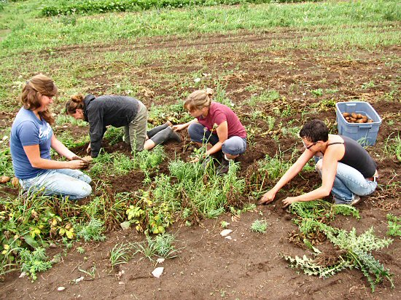
What is the connection to the Bahá'í Faith?
All the world's problems are in effect a result of striving for the material in place of the spiritual, living in disunity instead of free-flowing cooperation and common visions and goals, in a world whose lack of a world parliament and proper organisation ensures needed solutions are extraordinarily difficult to carry out.
All these things and more which through excess create imbalance, the Bahá'í World Community ultimately addresses and is developing itself to provide the human and organisational solution to.

