The Story of Ridván
This work is freely sharable with others:- please share the link to the latest version given at the end, rather than the document itself! Please see the end for maps.
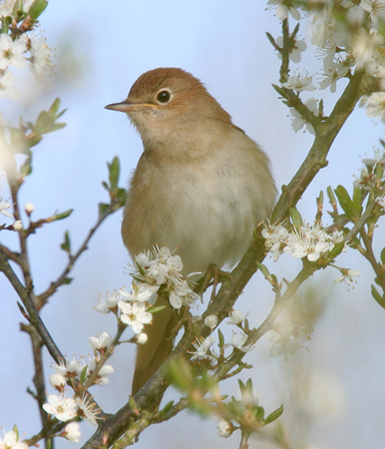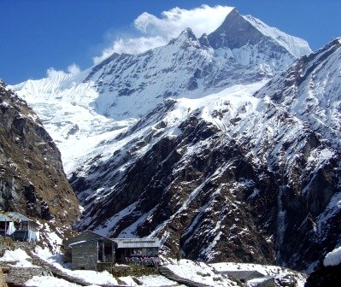

"Verily, all created things were immersed in the sea of purification when, on that first day of Ridván, We shed upon the whole of creation the splendours of Our most excellent Names and Our most exalted Attributes." (Kitab-i-Aqdas)

Introduction (1844-1852)
Withstanding the cruellest persecution, the Báb lifted up His voice like the awakening dawn, and stirring the sincere of heart for what was soon to emerge, gave Himself over to the restless bullets of a desperate enemy, and was set free to soar high beyond the expanse of the Heavens; as the echo of bullets faded, Bahá'u'lláh, crushed beneath iron chains, shone forth in the darkness, an incandescent Light unfurling a glorious new Day.....

Release from the Siyah-Chal
One day Bahá'u'lláh's brother was being chased by a gang, hoping to injure him. As he made it to the entrance of the Russian Consulate, they robbed him of his cloak. When the Russian Consul heard about this, and then learnt of Bahá'u'lláh's brutal imprisonment in an underground reservoir, he straight away rose up before the Shah and by using his great influence and pressure, brought about Bahá'u'lláh's release. Iran moved Bahá'u'lláh far away, to Baghdad; the Russians appointed guards to protect Him along the way, threatening that if a hair should be lost from His head, war would follow that would burn Iran to cinders.

Bahá'u'lláh in Baghdad
Bahá'u'lláh stayed in Baghdad for ten years; He shone before all men and spread the Call of God, every day inspiring life into the community of the Báb, and causing every heart to tremble with wonder.

Decision to Remove Bahá'u'lláh from Baghdad
Baghdad was very close to Persia and several of its shrine cities - a crossroads for Iranian pilgrims, and a haven and hotbed for political exiles. News of Bahá'u'lláh's extraordinary popularity with everyone poured endlessly into Tihran, and the authorities feared Bahá'u'lláh would influence their pilgrims, and perhaps use His rising prominence to threaten the Persian government. In their meetings and gatherings, they tirelessly searched for ways to bring about Bahá'u'lláh's expulsion, and the remorseless picture they built up filled the Shah with fear.
For three long years, they tried every plot, persuasion and pressure to cause Istanbul to hand Bahá'u'lláh over to them, or to drive Him away; they then sought other governments to do the same; but Istanbul stood solidly by Bahá'u'lláh. Arranging for learned scholars to expose Bahá'u'lláh as ignorant, they instead walked away wholly satisfied; inciting gangs and hired assassins to have Bahá'u'lláh killed violently, Bahá'u'lláh faced them unarmed, without fear or harm. The Persian Ambassador became so frustrated at their lack of success, he cut off all connection to that government and refused to see the Sultan's ministers, until, at last, Istanbul found no alternative but to yield and move Bahá'u'lláh away. The Shah asked the Sultan to wipe out Bahá'u'lláh's influence and ensure He was moved very far away. They made a deal, and a telegram was sent to Baghdad directing His move out to Istanbul.

Conveying the Message
The Governor of Baghdad however admired Bahá'u'lláh immensely. When he received this telegram, he was quite unable to convey it, and a great many times had to be ordered; he responded that Bahá'u'lláh had lived there ten years, and no fault was ever seen in Him. News of this telegram could not however be contained, and inevitably it began to spread.

Tablet of the Holy Mariner
Bahá'u'lláh was encamped with His followers in an open area outside the City to mark the new year, and after a few days His secretary came out from His tent, and with Bahá'u'lláh's companions all gathered round him, he began chanting to them the Tablet of the Holy Mariner. The friends had never before felt such overwhelming sorrow, as they began to realise the period of Baghdad was soon to close. He finished chanting, and then Bahá'u'lláh Himself spoke, comparing all the tents around to the distractions of the world: that they are no sooner spread, than they are rolled back. Observing this, He immediately ordered them folded up, and requested everyone's return to the City.

Messenger
The tents were still being put away, when a messenger arrived with an invitation to a meeting at the Governor's headquarters. He handed it to Bahá'u'lláh, Who accepted it; Bahá'u'lláh, however, made it known that His mission was not with rulers and officials, and had no cause therefore to meet at the Court House. Instead, He suggested meeting the next day in the mosque, just across the street from the Governor.

Tumult
A great tumult quickly seized and spread amongst Bahá'u'lláh's companions. Refusing to sleep or eat, many resolved to end their lives the moment they were parted from Him. Bahá'u'lláh with His loving-kindness gradually drew them away from their course, and resigned them to His good-pleasure.

Meeting at Mosque
The appointed hour came, and the Governor arrived at the mosque. He felt too ashamed to carry out his task, and sent in his deputy to pass on the order exiling Bahá'u'lláh to Istanbul, the capital of the Empire. The order was presented to Bahá'u'lláh in the mosque, and as the custom was, made His own choice. Bahá'u'lláh gave His decision to go there, and the government provided Him with money to make the journey. Bahá'u'lláh accepted it, and immediately distributed the money to the poor.
When Bahá'u'lláh was summoned before the magistrates, Abdu'l-Bahá stepped forward and declared his firm desire to go in Bahá'u'lláh's place; however Bahá'u'lláh prevented this, and went Himself. Great numbers of people assembled about Bahá'u'lláh's house, and when they saw Him leave, they were one and all thrown into the most visible grief, feeling He might never return to them.
The magistrates respected and loved Bahá'u'lláh immensely, and having found themselves unable to stop or change the exile, they apologised with great sorrow. Bahá'u'lláh remained in conference with them all day, yet no way was found to prevent the decree.

Initial Reaction to the News
His followers were still gathered about the house when the news arrived, and their hearts sank to the depths. The fierce natures of many Arabs present billowed to the surface with violent declarations, and they implored Bahá'u'lláh not to desert them, feeling that without Him as their shepherd they would die. Although desiring to go alone, His family wept and insisted so intensely that they accompany Him, He in the end agreed they could, and named those who would stay behind. He said they must prepare to set out on the exile in two weeks'. However, the next day they utterly overran the house, and no preparations were possible.

Progressive Allusion
Gradually Bahá'u'lláh began to convey to His future followers what was approaching. His festive, soul-entrancing poems and writings, the conversations He held and the change in His manner were full of hints of the prophetic office and leadership He was about to take on. Exaltation and sadness would flood His soul, and a boundless ecstasy filled His lovers' hearts.

Tablets Chanted
In the night time, His secretary would gather them all together in his room, close the door, and under the light of many fragrant candles, he would chant for them the newly-revealed poems and Writings in his possession. Immersed in the realms of the spirit, they would become oblivious of the world around, and forgetting entirely any need for food, drink or sleep, would suddenly discover the night having passed, and the sun approaching noon.

Preparations to Leave
The next few weeks were exceptionally busy. Bahá'u'lláh revealed a personal Tablet for every one of His friends in Baghdad, adult and child alike, writing for them with His Own hand; He received innumerable visitors, and made the practical preparations necessary for the caravan journey. The arrangements required for the journey were exceptionally demanding.

Decision for Ridvan
Bahá'u'lláh suggested moving across the River into the garden of one of His friends, and there with Abdu'l-Bahá receive the visitors, freeing the house from the turmoil of people and allowing the family to pack. The Master made the arrangements for Bahá'u'lláh to go to the Garden, and in every way he could, shielded Bahá'u'lláh from the pounding insistence of the world around.
This suggestion of moving out from the house was repeated amongst the friends and quickly became distorted, until a rumour circulated that Bahá'u'lláh was being taken away alone, and everyone came pouring in in masses, wild with grief and unable to be calmed.

Preparing the Garden
Provisions were moved into the Garden; a tent was set in the centre for Bahá'u'lláh, and other tents were ranged throughout the Garden, forming a little village.
The Garden was blooming with bright red roses, colourful flowers, tulips, and luxuriantly green trees. A pool of water stood in the middle of Bahá'u'lláh's tent, and everywhere outside, streams of water flowed in all directions. Everyone was devoted to making the Garden more beautiful than it had ever been.

Departure for the Garden - 22 Apr
On the appointed afternoon, in the nineteenth year of the Faith, the 22 April 1863, Bahá'u'lláh emerged from the inner room of the house, and set out with Abdu'l-Bahá toward the Garden that lay over the River, ten minutes from the City gate. On His head He now wore conspicuously a taj, a tall, beautifully-adorned felt hat that He from that moment on would wear throughout His ministry.

Gathering for Bahá'u'lláh
People of every rank, nationality and walk of life gathered from all quarters of the City and thronged the approaches to His house: men and women of every age, friends and strangers from every social class, the poor, the orphaned and the outcast, merchants, notables, clerics and officials, the vast majority unconnected to the Faith of the Báb, the Bahá'í ladies congregating together in the courtyard; all waited, amazed, heartbroken, and apprehensive.

Stepping Outside
As Bahá'u'lláh stepped outside, a rush of people poured forward from all directions, humbling themselves before Him, weeping greatly. Bahá'u'lláh stood for some time amidst the weeping and lamenting hearts, speaking words of comfort, and promising to receive each of them later in the Garden. When He had walked some way toward the gate, amid the crowds a child of just a few years rushed forward and clung to His robes, weeping aloud and begging in his tender voice that He not leave. They were lamenting the departure of One Who, for a decade, had imparted to them the warmth of His love, and the radiance of His spirit; Who had been the refuge and guide for all.

Into the Street
As He descended the steps from the courtyard into the narrow street, just before it joined the main road, the entire area was thronging with people, both believers and others, and all movement was impossible. Friends could not be distinguished from strangers, and the sound of lamentation and grief rose up everywhere from all alike. Suckling babies were cast under Bahá'u'lláh's feet. He raised those infants tenderly, one by one, blessing them, and gently and lovingly replaced them in their sorrowing mothers' arms, charging them to bring up those dear flowers of humanity to serve God in steadfast faith and utmost truth. Men threw themselves in His path, hoping that His feet might touch them and bless them as He passed. It took Him some minutes to place each foot upon the ground.
One man had an only child, which had come to him late in his life, and he stripped the clothes from the child's body and placing it at Bahá'u'lláh feet he cried, "Naked I give you my child, my precious child, to do with as you will: only promise not to leave us in distress! Without you, we cannot live."
Everyone was crying, pressing in to approach Bahá'u'lláh, to hear His words, touch Him or receive a comforting glance, howling and weeping at their loss, seeing no more value in life. Bahá'u'lláh bade each person farewell, caressing and soothing everyone.
Such grief they had, that all those who were to accompany Bahá'u'lláh sorrowed along with those to be left behind.

Toward the River
The streets and housetops all along His way were crowded with Bahá'u'lláh's friends; such a commotion Baghdad had rarely seen. Upon the way, and with an open hand, Bahá'u'lláh provided to the poor He had so faithfully befriended, uttering words of comfort to the disconsolate as they pleaded with Him on every side, until, at long last, Bahá'u'lláh managed to reach the banks of the River Tigris. As He prepared to cross, He entrusted the city of Baghdad to His devoted friends, that through their deeds and conduct the flame of love would continue to glow within the hearts of its people.

Crossing the River
Bahá'u'lláh boarded a small boat waiting for Him; the people pressed all around Him, wishing to be in His Presence for as long as they could.
The boat pushed off, and ferried Bahá'u'lláh across the water, in company with 'Abdu'l-Bahá, the Purest Branch, another of His sons, and His secretary; and the companions on the bank all watched with sorrowing hearts as He receded, into the distance.
Bahá'u'lláh set foot on the opposite bank and crossed into the Garden at two hours to sunset, just as the call of 'God is the Greatest' resounded throughout the district from the pinnacles of the mosque, summoning the inhabitants to the late afternoon prayer. Shortly after Bahá'u'lláh's arrival, the River rose up, making it difficult to cross, and it was only on the ninth day that the whole of Bahá'u'lláh's family went over to join Him.

Those Remaining on the Banks
An extraordinary exhilaration, a marvellous exaltation in the atmosphere filled the companions that day. As they remained watching on the bank, they were aware of this, yet unable to understand what in due time they would come to learn.
Seeing the boat reach the other side and Bahá'u'lláh disappear in the distance, they headed off on foot toward the main bridge floating on the River, making their way to the Garden, where food was cooking and tea prepared for the friends.

The Garden of Ridvan
For twelve days Bahá'u'lláh stayed in the Garden, and would be found each day in the utmost joy, walking majestically in the flower-lined avenues and amongst the trees.
The friends living in Baghdad would come during the day and return home each night, whilst others would be engaged in service to those in the Garden.
Eminent rulers, clergy and jurists would come continuously to Bahá'u'lláh's tent with their insoluble problems, and take their leave satisfied with their dilemmas entirely solved.

Day 1 - Mystery Manifest
On the very first day of the Ridván festivities, Bahá'u'lláh shone out to the world like the most brilliant sun. At that critical hour and without warning, amidst the unending multitude of interrupting visitors thronging His tent and the dangers such a news would bring to His exile, Bahá'u'lláh chose to lay bare the mystery surrounding His person, assuming the power and authority of the One promised by the Báb. He made known how the effulgence of the Eternal Truth had at that moment infused all created things with the life of every divine quality, immersing creation in the sea of purification; the sword was to be utterly cast from reach; and He made it known that the next Messenger would come to the world only after a thousand years. In such a way, and through many signs, Bahá'u'lláh conveyed His position to those who were present, and announced with great joy the start of the Festival of Ridvan. Though on the threshold of His exile into great suffering in far-away lands, yet sadness and grief entirely vanished from everyone's hearts, replaced with unclouded delight.

Daily
Each day in the Garden, before the sun had dawned, the gardeners would pick the roses which lined the four avenues and pile them up in the centre of the floor inside Bahá'u'lláh's tent. So great would be the heap that His companions gathering to drink their morning tea in His presence would be unable to see each other across it. Bahá'u'lláh would entrust these roses with His own hands to the friends He would send out each morning, on His behalf to be delivered to His Arab and Persian friends in the city.
Food was brought from the house of Bahá'u'lláh in Baghdad, where His family was still in residence, and also from another house. For some days there was much wind, and Bahá'u'lláh's tent was swaying about. The friends took it in turns throughout the night and day to sit and keep the tent ropes steady in case it should be blown down, their whole happiness in so doing being to be so near to Bahá'u'lláh.
Bahá'u'lláh would summon a number of His companions to Him each day, and dismiss them in the evening. Those without family ties were allowed to remain for the night, with the remainder returning to their homes.
Every morning and afternoon, Bahá'u'lláh would speak of the Báb's Cause and intimate His own; without any trace of sadness, He radiated forth the utmost joy.
The notables and ordinary devoted people of the City, yearning to visit Bahá'u'lláh, were unable to bear their separation, and would arrive from Baghdad each day in streams and a succession of waves, offering their last farewell, and take their leave with feelings of profound sorrow.

Day 5 - Roses
On the fifth night, one of the companions was watching beside Bahá'u'lláh's tent, keeping the ropes steady; as midnight approached, Bahá'u'lláh came out from His tent, and He passed by the places where some of His companions were sleeping. He began to pace up and down the moonlit, flower-bordered avenues of the garden. The nightingales were singing so loudly on every side only those nearby could make out His voice. Bahá'u'lláh continued to walk, and paused amidst an avenue. He observed how the nightingales were sleepless from dusk till dawn enraptured with their love for the roses, communing in a burning passion of melody... how, He asked, could those afire with the rose-like beauty of the Beloved, choose to sleep?

Day 5+ Visitors
For three nights the same companion watched and circled around His tent, and found Bahá'u'lláh wakeful at all times; whilst each day, from morning to evening, Bahá'u'lláh would be engaged in ceaseless conversation with the streams of visitors flowing continuously into His presence from Baghdad.

Day 8 - Declaration to Abdu'l-Bahá
Four days before Bahá'u'lláh's departure from the Garden, He called 'Abdu'l-Bahá to His tent, and there disclosed in clear terms that He was the One to be manifest by God, promised by the Báb.
As the Master heard these soul-stirring words, He understood why the Manifestation had once more received such persecution, and He came to see, as a radiant vision, the world of the future when the divine Message will have changed the heart of the world. From that moment onward, a new and increased joy and devotion took possession of him, and he consecrated his whole self, body, soul and spirit, to the sacred work of the Cause.
Later, within the Garden, Bahá'u'lláh made the same declaration to four others. The time was not yet to come for a public declaration, and He enjoined these few to keep their new understanding secret.

Day 9 - Family Arrive
On the ninth day, the River settled down and the flood-waters receded, and Baha'u'llah's family having completed their preparations crossed the boat bridge and into the Garden, and the River overflowed a second time.

Day 12
The flooding subsided again on the twelfth day, and everyone went across the River to enter the presence of Bahá'u'lláh.
The day at last came to a close, and Bahá'u'lláh announced that He would be leaving the coming afternoon.

Day 13
This news spread; throughout the final day, visitors and the authorities of Baghdad thronged to the Garden to present their final farewells.

Visitor - Alusi, the Mufti of Baghdad
A renowned jurist expert in the religious law was among the visitors. His eyes dimmed with tears, he heaped curses upon the Shah for bringing about Bahá'u'lláh's exile from Baghdad, exclaiming in a play on the monarch's name, that he was not the Helper but the Abaser of Religion.

Visitor - Governor, Namiq Pasha
The Governor himself, who had in place of himself sent a deputy to the mosque to convey the message of exile, crossed the river and visited Bahá'u'lláh. Expressing his utmost regret at the developments, he assured Bahá'u'lláh that whatever He chose to command, they would be ready to carry it out for Him. He handed a written order to the officer who would be accompanying Bahá'u'lláh, instructing the governors of the provinces near where the exiles would pass, to extend them the utmost consideration. Bahá'u'lláh assured him that they had everything necessary, and all along the route, Bahá'u'lláh never permitted them to accept the exactions instructed by the Governor, always buying and paying for their own supplies. To the Governor's insistent and repeated offers of service, Bahá'u'lláh requested that he keep in mind His loved ones and deal with them with kindness. The Governor assented to this with unhesitating warmth, and found good occasion to serve their needs and protect them from violent attacks.

Enemies' Regret
The Governor remarked that in the face of such deep-seated devotion, sympathy and esteem from high and low, those who had so tirelessly sought the order for His banishment and then rejoiced at their success, were now bitterly regretting their act, and had become even more insistent instead that He should remain!

Governor's Horse
The Governor also had a very beautiful horse, and wished to send it to Istanbul. He requested if Bahá'u'lláh's men might look after it, and this Bahá'u'lláh granted.

Departure from Ridván Garden
After much time, the mules were loaded; eight or nine howdahs settled on them and closed up, and the ladies and children took their seats, some of these of the most joltering kind. Different people would be serving in different ways. A Turkish owner of pack mules was in charge of the baggage; the Master was on horseback, and with a number of others was watching the animals. One man stood in charge of supplies, for lending out any needed articles and seeing they were returned. All the young men, and others able to ride, mounted on their horses or rode on mules, and in the late afternoon of 3 May 1863, at the moment of the full moon, the company began upon its way, escorted by some Turkish soldiers, who behaved very respectfully to the exiles even though they were prisoners. So extraordinary was the influence of Bahá'u'lláh's personality, that all who came within its lines of force were affected and offered their courtesy.

Horse Brought and Mounted
During His many years in Baghdad, Bahá'u'lláh had always chosen to ride a donkey rather than a horse. Towards sunset, amidst all the commotion, his lovers brought over an Arabian horse of the finest breed, the best they could afford. As Bahá'u'lláh's foot reached the stirrup, the red stallion bent its knees, and lowered itself, causing the people to lament ever louder. Bahá'u'lláh spoke to the horse approvingly as it recognised Who was about to mount him, and this remark burnt the hearts of everyone, until they became wholly unconscious of themselves. Bahá'u'lláh showered everyone with sweet words of consolation, and He waved farewell to all. As He mounted and was ready to depart, there was a great outpouring of grief. The lamentation, anguish and heart-rending, unbearable cries of distress of the friends and the sorrow and mourning of all the people was such that no one can ever depict. Time and again the call, 'God is the Greatest!' rang out from amongst the crowd.

Those who were to remain
Those who Bahá'u'lláh had indicated were to remain behind stood in a row. They were so entirely overcome with sorrow, that they all burst into tears. Bahá'u'lláh drew back up to them, and consoled them. He assured them it was better for the Cause that they should stay behind. He said that there were some with a tendency for causing mischief, and He was therefore taking them with Him. One of the friends was utterly beyond all control of anguish and sorrow, and addressed the crowd with a poem, declaring, "Let us all rise, to weep like the clouds of Spring; when lovers become separated from their Beloved, you hear even the wailings of the stones!"
Bahá'u'lláh was so moved by this, remarking how the poem was for just such a day.
Those fortunate enough to depart with Bahá'u'lláh were sobbing and crying with them, their tears pouring out of their eyes. The clergy, jurists, rulers and commoners were all crying and weeping with them.
Bahá'u'lláh mounted His horse again. One of the friends placed a sack of coins in front of the saddle, and Bahá'u'lláh distributed the coins amongst the poor who were standing by and wailing. They broke out of their order, and rushed over to Him in an unruly way. He showered the coins out among them, saying, "Gather them yourselves!"

Cannon Fired
The Governor was anxious in case Bahá'u'lláh should leave at a perilous astrological time, and hoped He would abandon the departure. He arranged for a cannon to fire at the very moment Bahá'u'lláh mounted His horse, so he would be able to determine the astrological conditions. As Bahá'u'lláh departed, the cannon burst out, and in great astonishment he discovered the sun had just moved out from the ill-omened sign into a favourable one, leaving him quite stunned by Bahá'u'lláh's effortless awareness of every detail.

On the Move
The steed moved, and everyone shouted, "God is most Glorious - Upon Him rest Majesty and Splendour!" That day witnessed for the first time Bahá'u'lláh's splendid horsemanship. Heads on every side bowed down to the dust at the feet of His horse and kissed its feet; countless individuals pressed forward to embrace His stirrups. Many cast themselves in front of the horse, preferring death to separation. It seemed as if it were a heavenly steed passing over blessed bodies and pure hearts. Throughout the multitude was the murmur and cry that the tumult of the Hour of Gathering and Resurrection was unfolding before their very own eyes. Each would speak with his neighbour of the mysteries of this Manifestation.
The scenes of tumultuous enthusiasm were as spectacular and even more touching than at His departure for the Garden. Believers and unbelievers alike sobbed and lamented, and the chiefs and notables congregated there were struck with wonder, as no one escaped the all-encompassing emotions, rising up to such heights that no tongue could ever describe.
Among the bowing and fervent multitude of admirers, the affection and grief was visible all around. Through the power of God, Bahá'u'lláh rode forth from the Garden with such majesty and power as none could fail to acknowledge. The marks of homage and devotion continued to surround Him until He reached Istanbul.

Left Behind
Those left behind saw Bahá'u'lláh disappear from their sight toward an unknown destination, amidst the company of his family and twenty-six disciples. Sad at heart and utterly distressed in soul, as they returned empty-hearted and disconsolate to Baghdad, little did they know that Bahá'u'lláh was like the sun starting to rise towards its zenith; yet they felt unspeakable joy surging within them, overcoming all their bitter sorrows with a great and mysterious radiancy. The friends gathered together and encouraged each other to spread out and teach what had just been declared, and though actively serving the Cause, all their hearts wished for was to find their way near to Bahá'u'lláh.

Following Bahá'u'lláh
Bahá'u'lláh made it known that anyone accompanying Him on the journey without permission would come to no good. Many of His friends chose to abandon Baghdad nevertheless and accompany Bahá'u'lláh in His wanderings.
One companion ran after Him for three hours. Bahá'u'lláh saw him, and getting down from His horse, awaited him. He told him with His beautiful voice full of love and kindness, to go back to Baghdad, and with the friends set about work full of energy and joy.
Bahá'u'lláh comforted him, saying He was leaving the friends He loved in Baghdad and would send them news of His welfare, and counselled them to be steadfast in their service to God and accept His Will, living in such peace as they might be allowed.
They watched Bahá'u'lláh disappear off into the darkness with sinking hearts, knowing His enemies were powerful and cruel, not knowing where they were all being taken. Weeping bitterly, they turned their faces sooner or later toward Baghdad, determining to live according to His command.

Learning of the Declaration
Whether journeying with Him or remaining in Baghdad, most of Bahá'u'lláh's companions only began to learn of His momentous declaration once He had reached Edirne and begun to spread it publicly.
As this news reached every ear, the friends were transported into worlds of exultation and new insight that shone constantly in their hearts and guided them throughout the years.

Journey to Istanbul (Constantinople)

Firayjat Garden
After two hours, with the sun about to set, they reached a fertile garden three miles away on the bank of the Tigris, where they waited for Bahá'u'lláh's brother to wrap up all the affairs in Baghdad and bring with him the remainder of the packing. They set out the horses on a run to test them; and once again Bahá'u'lláh displayed His masterly horsemanship. All the while, people continued to arrive daily from Baghdad, unable to bear separation from the presence of Bahá'u'lláh.

Starting, Overview
At last, they set off, in a caravan of fifty mules, under the guard of ten cavalrymen and an officer, with seven pairs of howdahs, each pair topped with four protective shades, on a thousand-mile journey north-west to the capital Istanbul, through picturesque but arduous uplands, valleys, gorges, mountain passes, woods and pastures, negotiating narrow roads over dangerous precipices, and amidst the ever dangerous presence of highwaymen and thieves.

Generally
The journey was made in many small steps, along paths that did not always bear a name. Whenever the following stage was nearby, they would travel under the sun and rest during night; and when it was far off and the heat great, they would journey in the cool of the night and reach camp by morning or noon and then rest.
Along the way, sometimes friends were permitted to join the company, and others might make their return; and as they journeyed, Bahá'u'lláh's melodious voice could sometimes be heard, and His words at times recorded.
One of the companions made it his own special task to bring joy, delight and laughter to Bahá'u'lláh, and to dance in front of His horse.
Many of the friends would fall asleep or sleepwalk upon the way, and most riders dropped asleep at some stage and fell from their horse; sometimes they would awake, and climb a hill to spot where the distant tents lay, whilst Bahá'u'lláh would send out riders to find any missing people and return them to the caravan.

Bahá'u'lláh and Abdu'l-Bahá
'Abdu'l-Bahá, a gracious and energetic youth of nineteen, strove hard to make the toil of the long journey less arduous for everyone. At night He was among the first to reach the halting-place, and to see to the comfort of the travellers. When supplies were scarce, He spent the night in search of food. At dawn He would arise early, setting the caravan upon another day's march. Whenever Bahá'u'lláh placed His feet in the stirrup, 'Abdu'l-Bahá would then also mount His steed. The whole day long, He would ride in attendance of Bahá'u'lláh, and when Bahá'u'lláh would ride in the small mounted cover, 'Abdu'l-Bahá would ride the horse, sometimes behind, on the right, to the left, or in the midst of the caravan, keeping everything in his glance, whilst Bahá'u'lláh was surrounded by companions sometimes chanting their poems. All necessary instructions were given solely by 'Abdu'l-Bahá.

Stages (Arrival)
On approaching each village or town, Bahá'u'lláh's tent would be carried ahead and prepared, and the escorts would send to nearby locations official communication of an approaching honoured Guest. Bahá'u'lláh would mount His horse and meet the governor, nobility, clergy, jurists, officials and the notables, who all invariably came out to meet and accompany Him into the town or village. The mounted escort would stride ahead with banners and beating drums, and the majority of the nearby people would crowd upon the housetops and fill the streets, awaiting their arrival in welcome, it being widely known that the leader of the Bábis was on His way to Istanbul. On their arrival, the other tents would be set up and prepared.

Stages (Stay)
The company would stay a few days at each stop, generally remaining outside the towns. With the populace gathered, Bahá'u'lláh would teach them the Faith of God, with loving kindness for all, whilst the people would ask many questions. Most of the people were met by 'Abdu'l-Bahá. Some of the scholars and clergy presented most elaborate queries, and received answers that so filled them with admiration, they sang out Bahá'u'lláh's praises in whatever gatherings they attended, so that His eminence became evident everywhere.
The towns and villages held great festivities in His honour, preparing and bringing food for His acceptance. They eagerly sought to provide for His comforts, and special gifts would often arrive such as ice to cool them in the heat; whilst receiving these gifts, they always endeavoured to purchase the necessary supplies themselves. Some places had a great scarcity, and lacked even the food for their animals, whilst at other places it was extremely cold. Many stopping places were along the River, and on most days Abdu'l-Bahá and the companions would go bathing.
Throughout the night, a large number of the nearby inhabitants would surround Bahá'u'lláh's tent and guard and protect it until morning, staying awake so that they might sleep.

Stages (Departure)
Whenever the time rose for departure, the caravan of luggage and tents would be sent ahead, the howdahs readied and occupied by the women and children, and also Bahá'u'lláh's small covered mount prepared. With the family departing and Bahá'u'lláh's tent dismantled, His mount would be brought over with a small stepladder and He would take His seat.
A dignified delegation would escort them out for a considerable distance, and a mounted escort of half a dozen guards would be provided for security along the road.
Governors and the highest-ranking officers travelled continually along this route; yet never before had anyone witnessed anyone travel with so great a majesty and present such hospitality to all.

Arrival at the Port of Samsun
At last, after three and a half months of travel, they reached the port on the Black Sea. They stayed here a few days, and were met with respect by several high officials. Those looking after the pack animals were discharged generously, whilst the household horses were led onto a Turkish steamer, along with the horse being sent by the governor. The company of exiles finally reached Istanbul at noon a few days later, on 16 August 1863.

In Istanbul
So began the most tragic and yet most glorious period of Bahá'u'lláh's Call, with unprecedented trials and hardships mingling with the noblest spiritual triumphs. Bahá'u'lláh's ministry was about to reach its climax, and the catastrophic processes prophesied, to set in motion.
In Istanbul they were prisoners in a small and overcrowded house. Their quarters improved; but after four months, through the continued pressure and defamation of the Persian government, they were suddenly and unjustly banished by the Sultan and his ministers to Edirne on the extremes of the empire during the depths of winter. Bahá'u'lláh refused to give the envoy an audience, and after three days sent a response conveying a summary of the ministers' conduct. When the Grand Vizir studied it, he immediately turned the colour of a corpse, and the messenger hastily left his presence.

Journey To Edirne
Leaving their weeping friends behind in wagons, carts, pack animals and oxen, the company set out under Turkish escort, with snow falling heavily most of the way. Even the eyes of their enemies wept for them. The cold was so severe, the great Euphrates River froze. Without proper clothing and food, as they crossed the bleak and windswept country, their sufferings were extreme.

In Edirne
For the first winter in Edirne, Bahá'u'lláh and His family were in a small, comfortless and vermin-infested house; in the springtime, their accommodation improved, and they remained in Edirne for four and a half years. Bahá'u'lláh began teaching, and there quickly gathered round Him a large and devoted following.
In Edirne Bahá'u'lláh publicly announced His mission, and the followers of the Báb accepted Him enthusiastically, and became known as Bahá'ís. Amidst the violent woes and crises, He issued Tablets of declaration to the secular and ecclesiastical leaders of the entire world. He sent further a special Tablet of Declaration to His half-brother, who, drunk with jealousy, mounted against Him a lifelong crusade of violent and unscrupulous opposition. The troubles and woes caused by those hostile to the new message were such that the Turkish Government banished them all, exiling Bahá'u'lláh to the prison-fortress of Akka in Palestine, and His half-brother to Cyprus.

Akka and Beyond
In Akka the bedrock and Covenant of the Faith was laid down, establishing in turn the unity and unfoldment of its influence through Abdu'l-Bahá, the organic strength of its implementation through Shoghi Effendi, and finally, under the guiding arm of the Universal House of Justice, the Faith is destined over the course of coming centuries to reach its extraordinary era of maturity.

The history that follows, is written by you and your friends...

Info
Author : David Merrick, Edinburgh
All comments appreciated : paintdrawer.co.uk/david/email.php
This Version : 2026-07-30 15:31
Latest Version : paintdrawer.co.uk/david/folders/Spirituality/005=Collections/holydays.htm
See Also : Sources • Other Stories
Photos and maps follow on the next page

Garden of Ridvan (Photos and Map)
Glimpsed through Photos taken decades later when it was a hospital

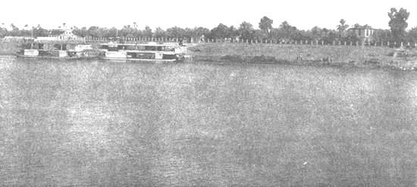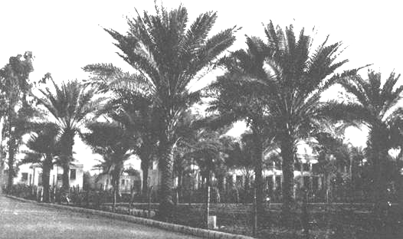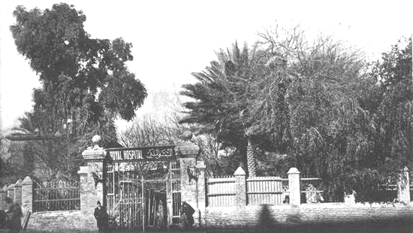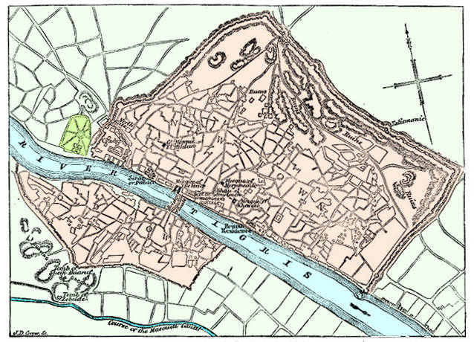

Bahá'u'lláh's Exile (Map)
Adrianople is Edirne, and Constantinople is Istanbul

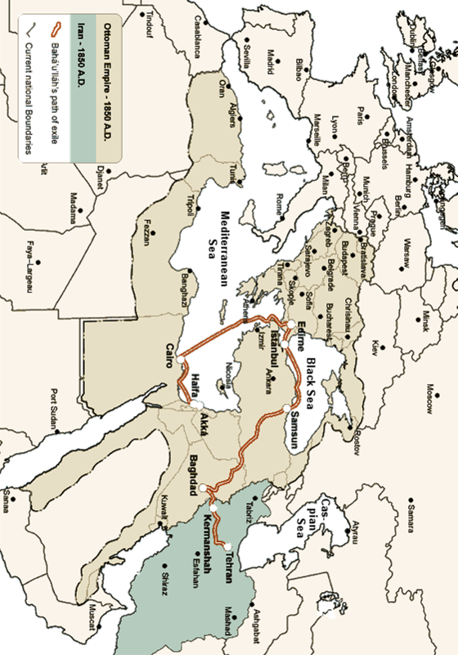

The theme of this Tablet is the story of the Covenant and man's unfaithfulness to it.
Ridvan means 'good pleasure'. It is used in the Qur'an for God's satisfaction with the believers in heaven. The angel standing before paradise is called Ridvan, and so the word has thereby come to convey 'paradise'. The Ridvan (Najibiyyih) Garden in Baghdad is different to the Ridvan Garden belonging to Bahá'u'lláh outside 'Akka. The Garden of Ridvan was a large agricultural area immediately north of Baghdad city walls, on the east bank of the River Tigris, about 450 metres from the Mu'azzam gate, and directly across the river from the district where Bahá'u'lláh lived. Being on the road of exile to Istanbul, it was well-placed to assemble the caravan for the journey and receive visitors. Early images show it as a wooded garden. Najib Pasha built a palace there and a wall around the garden. Dying in May 1851, the garden was presumably in his heirs' hands at the time of this story. It was purchased by the government in 1870 to use as a guest house for the Shah's visit, and in the 20th century, the Royal Hospital was established there, now Medical City, a large modern teaching hospital.
For this and other passages, in the cultural language of the times a person of lower social status will visit someone of higher status, and not the other way around.
Mirza Mihdi
Bahiyyih Khanum's statement, in The Life and Teaching of Abbas Effendi by Myron Phelps.
People had been crossing anyway to carry food so perhaps this was more of an opportune moment to get the larger items across. The timing of the 9th Day of Ridvan as a Holy Day one assumes is unconnected to the crossing; Shoghi Effendi's explanation is that 9 was chosen as a symbol of perfection, and it may therefore be tied in to the Declaration Baha'u'llah made at that time.
Istanbul / Constantinople, where the Black Sea meets the Mediterranean, was Capital of the Eastern Christian Byzantine Empire and then the Muslim Ottoman Empire.
Some 75 or so people.
The Alcatraz of its time, where the worst murderers and criminals were sent to die.

